
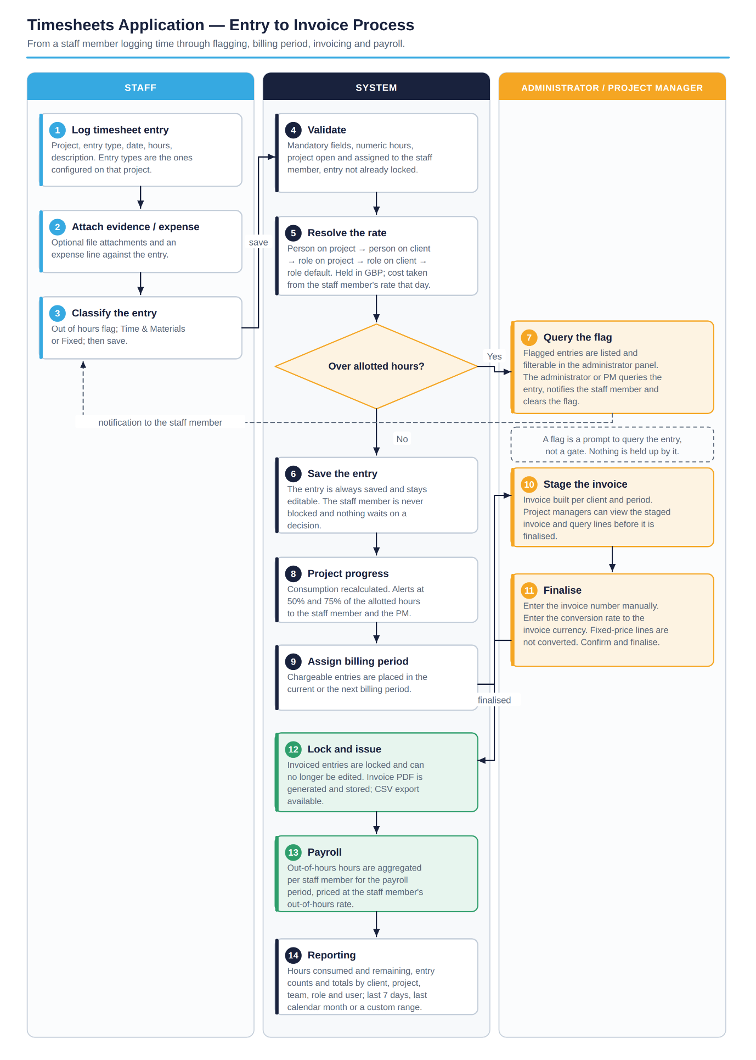

Timesheets

Table of Contents
Introduction 2
Business Requirement 3
Objectives 3
In Scope 4
Authentication and User Management 4
Staff 5
Staff Roles and Rate Cards 5
Clients and Projects 6
Timesheet Entries 7
Flagging 7
Invoicing 7
Currency 8
Payroll 8
Reporting and Exporting 8
Notifications 8
Data Validation and Presentation 9
Data Migration 9
Out of Scope 9
Requirements 9
Technical Architecture 10
Application Components 12
Key Design Decisions 12
Key Entities 13
Process Flow 14
Document Approval 15

Introduction

The timesheets app is a crucial solution for SVGIT. It is the application that drives the invoices in the business.

Business Requirement

The Timesheets application needs to bridge the following gaps and fulfil these needs for the business:
- Staff members must be able to log their work via Timesheets against specific projects against specific clients
- Management must be able to create invoices based on timesheet entry data provided by staff members
- Management must be able to calculate payroll based on the out of hours work entered timesheets
- Management must be able to actively convert between currencies for different clients such as from GBP -> USD
- Staff members must be able to put lines regarding expenses and add relevant attachments
- Management must be able to maintain staff roles in the application so rate cards can be assigned to them
- Management must have the ability to export relevant data such as data from reports, timesheet entries from individuals and roles
- Management and users must be able to have visibility on how projects are progressing, ideally via push notifications to the application which will be initially marked at 50% / 75% but must be able to be changed by management in the settings
- Everyone in SVGIT that has been selected to use the application must be able to access via their work accounts using Microsoft Entra (Formally Azure Active Directory)
- Management must have the ability to maintain invoices and change entries before the invoice has been sent to the client.
- The application needs adequate notifications to be shown for both the user and management. If entries are flagged, management must be able to flag from their panel and send a notification to the relevant user.
- The application must inherit from previous data structures that were used in the legacy version on Power Apps

Objectives

The objective of this development is to replace the legacy Power Apps timesheets application with a purpose-built web application that SVG IT owns and maintains end to end. The new application must remove the manual effort and the administrative friction in the current solution while protecting the data that invoices are raised from.

The development will be considered successful when the following objectives have been met:
- Consolidate the administration screens. The current administration area is split across Staff, Staff Costs, Customers, Projects, Admin Overview, Impersonate and Revert. Staff and Staff Costs are to be brought together into a single Staff screen from which a staff member, their costs and their project assignments are all maintained.
- Remove per-user rate maintenance. Charge rates are to be driven by roles and rate cards so that a rate can be set once against a role for a client, rather than being applied to each individual staff member by hand.
- A custom rate can still be set for a specific person on a specific client or a specific project where one has been agreed.

- Protect invoiced data. Once a timesheet entry has been included on an invoice it must be locked and no longer editable, so that the figures an invoice was raised from cannot change after the event.
- Give management visibility before a project overruns. Consumption against a project must be visible as a percentage of the time allotted, with notifications raised at 50% and 75%.
- Automate payroll for out of hours work. Out of hours time entered on timesheets must feed a payroll calculation rather than being worked out separately.
- Support invoicing in the client's currency. Rate cards are held in GBP and converted at a rate entered by the user at the point the invoice is generated.
- Provide self-service extracts. Users and administrators must be able to export entries and report data to CSV without a developer being involved.
- Improve data quality. Server-side validation, consistent grammar and consistent labelling throughout the application.

In Scope

The scope of this development is the complete Timesheets application, delivered as an Angular front end with a .NET (C#) Azure Functions back end and a SQL database. The functional scope is set out by area below.

Authentication and User Management
- Access to the application is via Microsoft Entra single sign-on. There are no local passwords.
- An administrator can enable or disable any account within the SVG IT tenancy. Accounts are never removed automatically; a user is only removed when an administrator removes them.
- Only active users can be impersonated and only admins can impersonate users.
- Inactive users do not appear anywhere in the application other than on the Staff screen, where they can be filtered on and reactivated.
- An administrator can impersonate a user and edit that user's timesheet entries while impersonating. The impersonated session is clearly signposted in the interface and every action taken while impersonating is recorded against both the administrator and the impersonated user.
- Reverting from an impersonated session returns the administrator to their own account.

Staff
- A single Staff screen replaces the existing Staff and Staff Costs screens.
- The screen is filterable and searchable, at a minimum on administrator, active or inactive, role and project.
- From the Staff screen an administrator can set whether a staff member is an administrator and whether they are active.
- Staff costings are maintained on the Staff screen. An hourly cost is set against the staff member.
- Staff costs are effective dated. When a cost changes, the new cost applies from the date it takes effect and existing timesheet entries and invoices are not affected.
- Projects can be assigned to a staff member directly from the Staff screen, as well as from the project itself.

Staff Roles and Rate Cards
- Roles are set up in the application and a rate card is assigned to each role.
- Rate cards are always held in GBP as the base currency.
- An administrator can override a role's rate for a specific client, so that a rate is set once for the role and the client rather than for every user individually. This is the mechanism that removes the per-user rate maintenance in the current application.
- An administrator can override a role's rate for a specific project, where a single project has been agreed at a rate that differs from the rest of that client's work.
- An administrator can set a custom rate for a specific individual against a specific client. That rate applies to that person on all of that client's projects and overrides the role rate.
- An administrator can set a custom rate for a specific individual against a specific project. That rate applies to that person on that project only and takes precedence over every other rate, including their own client-level rate.
- Individual overrides are the exception rather than the rule. Where no override exists the person is charged at the rate for their role, so a new starter picks up the correct rates as soon as they are given a role and assigned to a project.
- The rate applied to a timesheet entry is resolved by taking the most specific rate that exists, working down the order below and stopping at the first match:

 | Rate set against | Typical use
1 | A person, on a specific project | One individual charged at an agreed rate on a single project, regardless of their role rate or their rate for that client.
2 | A person, on a specific client | One individual charged at an agreed rate across all of that client's projects.
3 | A role, on a specific project | Everyone in that role charged at a project rate, where a single project has been agreed at a different rate.
4 | A role, for a specific client | Everyone in that role charged at the rate agreed with that client. Set once against the role and the client; no per-user maintenance.
5 | A role (default) | The standard GBP rate card for the role, used where nothing more specific has been set.

Where an individual has both a client rate and a project rate, the project rate wins for that project and the client rate continues to apply to that client's other projects. The rate that was resolved is written to the timesheet entry, so an entry always shows which rate was charged and why.

- Rate cards and overrides are effective dated on the same basis as staff costs; a rate change does not alter entries that have already been recorded.
- The screen shows, for any staff member, the rate that will be applied on each project they are assigned to and whether that rate comes from their role or from an override.

Clients and Projects
- A project is set up against a client and staff are assigned to the project.
- Projects are split by type: Development, Support and Contract.
- A project is either a fixed one-off piece of time or repeating time on a monthly basis, controlled by the billing or invoice period held against the project.
- A project carries a flag controlling whether it is invoiceable.
- The project list shows a count of how many staff are assigned to each project.
- Timesheet entries against a project can be recorded as Time and Materials or as Fixed.
- Entry types are configurable against the project, so that only the entry types that are relevant to that project can be selected on an entry. Only projects of type Contract accept contract entries.
- A project holds the time allotted to it and shows completion as a percentage of the time used against that allotment.
- A project holds an estimated cost and an estimated profit, calculated per user and per role from the assigned staff, their costs and the applicable rate cards.
- Attachments and documents can be held against a project for users to view the documentation surrounding it.
- A project manager is nominated against each project.

Timesheet Entries
- A staff member records time against a project for a client, selecting the entry type, the date, the hours and a description.
- Attachments can be added to a timesheet entry.
- An expense entry can be recorded, with its own value and currency and an indication of whether it is rechargeable to the client.
- An out of hours structure is applied to entries so that out of hours work is identified at the point of entry and can be charged and paid differently to standard hours.
- Users are never blocked from adding time. Where an entry takes a project over its allotted time the entry is still saved and is flagged for query by an administrator or the project manager. There is no approval step and nothing is blocked.
- Entries that have been included on an invoice are locked and cannot be edited.

Discounts
- A discount can be applied in two places only: against a rate card before the invoice is produced, and against an individual invoice line while the invoice is being staged. There is no discount at any other level.
- A discount cannot be applied to a timesheet entry, and there is no whole-invoice discount.

Flagging
- Where a timesheet entry takes a project over its allotted time, the entry is flagged on the timesheet and raised to the administrator and the project manager.
- There is no approval step. A flag is a prompt to query the entry, not a gate: the entry is saved, remains editable by the staff member, and is carried through to invoicing in the normal way unless someone changes it.
- Flagged entries are listed in the administrator's panel and can be filtered on, so that queries can be picked up without going through every project.
- An administrator or project manager can send a notification to the staff member about a flagged entry, and can clear the flag once the entry has been queried and settled.
- Entries can also be flagged manually by an administrator or project manager where they want to query something that has not tripped the allotted time rule.

Invoicing
- Invoices are generated per client for a billing period from the chargeable entries in that period.
- When an entry is invoiced the user can choose to add it to the current billing period or to the next billing period.
- The invoice number is entered manually rather than being generated by the application.
- A staged invoice can be reviewed and amended before it is finalised. Project managers can view the staged invoice for their projects.
- The finalised invoice shows the staff member's name, the project name, the task date, the description, the total hours, the rate and the amount.
- An invoice can be exported and a PDF generated from it.
- Finalising an invoice locks the entries it was built from.

Currency
- Currency conversions are ALWAYS done at point of invoice otherwise the whole system uses its default currency which is GBP.
- Rate cards always start in GBP and are converted to another currency where required.
- A client has a currency to charge in and a currency to invoice in.
- Conversion is always applied from the local currency first.
- Fixed rates are not subject to conversion.
- When an invoice is generated the user enters the conversion rate to be applied. The rate used is stored against the invoice so that the invoice can be reproduced exactly.

Payroll
- Payroll for out of hours time is calculated from the timesheet entries recorded as out of hours.
- Out of hours hours are aggregated per staff member for the payroll period and priced at that staff member's out of hours rate as it stood at the date of the entry. Out of hours work must be approved by project managers or administrators so an approval process must be in place for this.

Reporting and Exporting
- Reporting covers historical hours, hours consumed and hours remaining per project and per client, the number of entries, and totals for projects and clients on a team, role and user basis.
- Entries can be exported to CSV. The export is available from the settings page for both users and administrators.
- Data can be exported on a client, project or project manager basis, for all users or for specific users.
- Every data extract offers the last 7 days, the last calendar month, or a custom date range.

Notifications
- Notifications are raised to the user and to management within the application.
- Project feedback notifications are raised at 50% and 75% of the time allotted to a project, indicating whether the project is on course to be completed within its allotment. The percentages are held in settings and can be changed by management.
- Where an entry is flagged, management can flag it from their panel and send a notification to the relevant user.

Data Validation and Presentation
- Validation is applied on the server as well as in the browser, so that data cannot be written by bypassing the interface.
- Mandatory fields, numeric and date formats, and permitted values are enforced on entry.
- Grammar, spelling and labelling are corrected and made consistent throughout the application.

Data Migration
- The data model inherits the structures used in the legacy Power Apps version so that existing records can be brought across.
- Staff, clients, projects, roles and rate cards are migrated from the legacy application.

Out of Scope

The following items are not included in this FDD. Any of them can be quoted separately as a later phase of work:
- Integration with an accounting or finance package. Invoices are produced by the application and exported; they are not posted automatically into a finance system.
- An automated foreign exchange rate feed. Conversion rates are entered manually by the user at the point the invoice is generated.
- A native mobile application. The application is a responsive web application accessed through a browser.
- A client-facing portal. Clients do not log in to view or approve time.
- Purchase order management, resource scheduling and forward capacity planning.
- Holiday, absence and other HR functionality.
- Automatic capture or scanning of expense receipts. Receipts are added as attachments.
- A formal timesheet approval workflow. Entries are not submitted for approval and are not approved or denied; entries that need attention are flagged for query instead.
- Bulk migration of historical timesheet entries and historical invoices beyond the reference data set out under Data Migration above.

Requirements

The following foundational requirements need to be confirmed to support the successful development and implementation of the Timesheets application:

• Microsoft Entra tenancy:
An application registration in the SVG IT tenancy with the appropriate delegated permissions and administrator consent, so that sign-in and directory lookup of tenancy members can be performed.
• Azure subscription:
A subscription and resource group for the application, providing Azure Static Web Apps, Azure Functions, Azure SQL Database, Azure Blob Storage, Key Vault and Application Insights.
• Legacy application data:
An export of the current Power Apps solution data covering staff, clients, projects, roles and rates, so that the data model can inherit the existing structures and the reference data can be migrated.
• Commercial reference data:
The confirmed list of roles, the GBP rate card for each role, the client-specific rate overrides that are already in use, and the hourly cost for each member of staff.
• Out of hours definition:
The hours and days that constitute out of hours, and the basis on which out of hours time is charged to the client and paid to the staff member.
• Invoice format and numbering:
The invoice template and branding to be used for the generated PDF, and the numbering convention that the manually entered invoice number must follow.
• Billing periods and project managers:
The billing period for each client and the nominated project manager for each project.

Technical Architecture

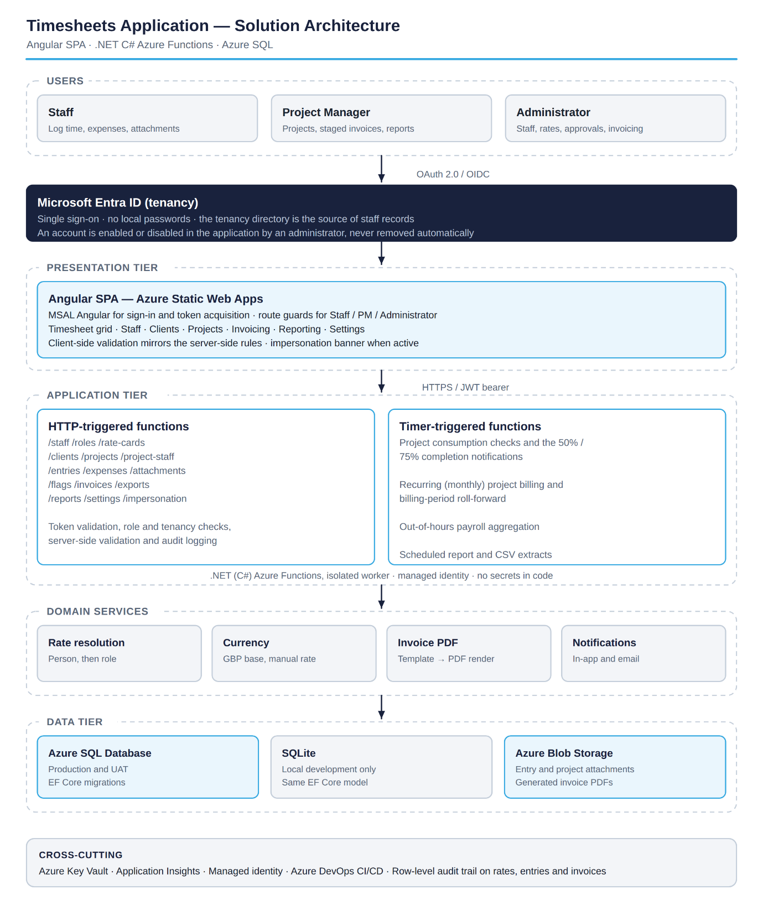
The diagram below illustrates a high-level overview of the proposed system architecture, outlining the end-to-end data flow and the key integration points across the platforms involved in the development.

Application Components
- Angular single page application. Hosted in Azure Static Web Apps. Signs the user in with MSAL and holds the timesheet grid, the Staff, Client, Project, Invoicing, Reporting and Settings screens. Route guards restrict screens by role.
- .NET (C#) Azure Functions. HTTP-triggered functions provide the API used by the front end. Every request is validated for a valid token, for tenancy membership and for the caller's role before any data is returned or written.
- Timer-triggered Azure Functions. Handle the work that runs on a schedule rather than on request: project consumption checks and the 50% and 75% notifications, monthly recurring project billing and billing period roll-forward, and out of hours payroll aggregation.
- Azure SQL Database. The production and UAT database, built and versioned through Entity Framework Core migrations. SQLite is used for local development against the same model so that developers do not need a database instance.
- Azure Blob Storage. Holds timesheet and project attachments and the generated invoice PDFs. Files are not stored in the database.
- Microsoft Entra ID. The identity provider and the source of the tenancy directory used to enable staff within the application.

Key Design Decisions
- Rates and costs are effective dated rather than overwritten. Changing a staff member's hourly cost or a rate card creates a new record with an effective date. Existing entries keep the rate and cost that applied when they were recorded, so historical invoices and reports remain correct.
- The rate applied is stored on the entry. As well as resolving the rate at the point of entry, the resolved rate and cost are written to the entry itself. An invoice can therefore always be reproduced from its own data.
- Locking is enforced in the API, not only in the interface. Once an entry is attached to a finalised invoice, any update to it is rejected by the API.
- GBP is the base currency throughout. All rate cards and all stored amounts are held in GBP. Conversion happens only at the point an invoice is generated, using the rate the user entered, and that rate is stored against the invoice. Fixed-price lines are excluded from conversion.
- Impersonation is audited, not hidden. Actions performed while impersonating are written to the audit log against both the administrator and the impersonated user.
- Staff records are disabled, never deleted. Because entries, invoices and payroll all reference a staff member, records are deactivated so that history is preserved.

Key Entities
The data model inherits the structures used in the legacy application. The principal entities are:

Entity | Purpose
Staff | A member of staff, linked to their Entra account. Holds whether they are an administrator and whether they are active.
StaffCost | Effective dated hourly cost for a staff member. A change creates a new record and does not alter existing entries.
Role | A role that a rate card can be attached to, for example Developer or Consultant.
RateCard | An effective dated GBP hourly rate. Scoped to a role or to an individual, and optionally narrowed to a specific client or a specific project.
Client | A client, with the currency to charge in, the currency to invoice in and the billing period.
Project | A project for a client. Holds the project type, the billing model, the invoiceable flag, the allotted hours, the estimated cost and profit and the project manager.
ProjectStaff | The assignment of a staff member to a project, with the role they hold on that project and any rate override.
EntryType | The entry types configured against a project, controlling what can be selected on an entry.
TimesheetEntry | A unit of time recorded by a staff member against a project. Holds the hours, the out of hours flag, Time and Materials or Fixed, the flagged state, the locked flag and the rate and cost applied.
Expense | An expense recorded against an entry or a project, with its value, currency and whether it is rechargeable.
Attachment | A file held against a timesheet entry or a project, stored in Blob Storage.
EntryFlag | A flag raised on an entry, automatically where it takes a project over its allotted time or manually by an administrator or project manager, with the reason and whether it has been cleared.
Invoice | An invoice for a client and a billing period. Holds the manually entered invoice number, the status, the invoice currency and the conversion rate used.
InvoiceLine | A line on an invoice: staff name, project name, task date, description, total hours, rate and amount.
PayrollPeriod | Aggregated out of hours time per staff member for a payroll period.
AuditLog | A record of who changed what and when, including who was impersonating at the time.

Process Flow
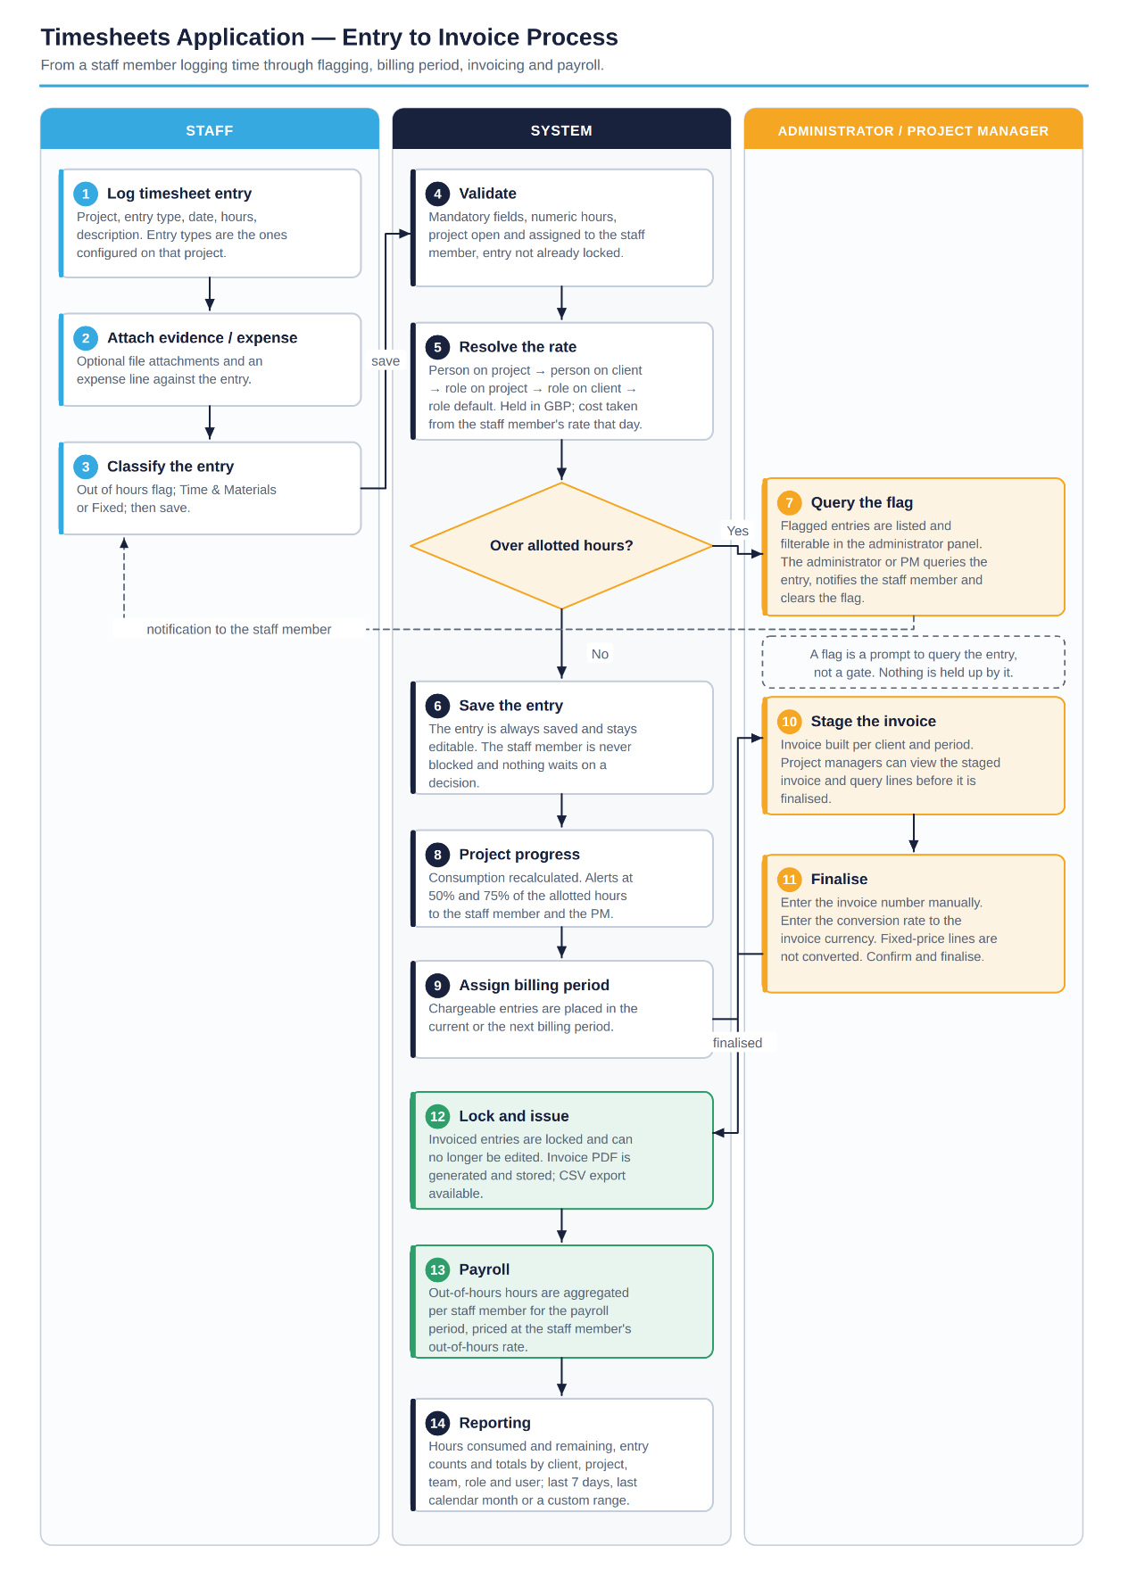
The diagram below sets out the end-to-end process from a staff member logging a timesheet entry through flagging, billing period assignment, invoicing, locking and payroll.

Document Approval

I hereby accept this Functional Design Document and authorise SVG IT to complete the development of the proposed solution as described in this document.

Name (SVG IT): _____________________________
Signature (SVG IT): _____________________________
Date: _____________________________

Name (Approver): _____________________________
Signature (Approver): _____________________________
Date: _____________________________

